ANALGESIC PRESCRIBING RATIONALE

Analgesics, above all other prescribed items, have the greatest potential for abuse, and are probably the most commonly prescribed item (usually as the last thought or request in a consultation). Not surprisingly they are often chosen as a target for markers of good prescribing.

There are ongoing trials comparing effectiveness, and these are best expressed as numbers needed to treat to gain at least 50% reduction in levels of pain. The Oxford pain control collaborative have collated these studies and this is graph summaries relative effectiveness for ACUTE pain.

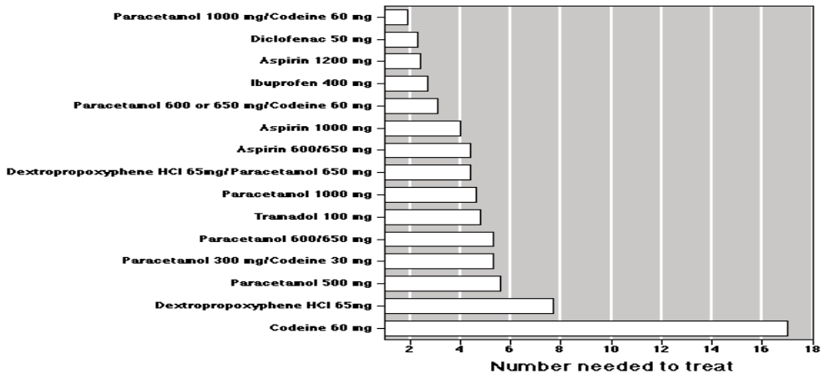

A number of important points can be derived from this
- Note the relatively poor effect of codeine alone but in combination with paracetamol is the most effective analgesic.
- Coproxamol and Tramadol are little better than paracetamol alone. Coproxamol not surprisingly is a poor analgesic because it combines a sub therapeutic dose of paracetamol with dextropropxyphene- a poor analgesic that is really more sedating, and as I am sure your experience will have shown, quite addictive. In addition it interacts with warfarin and other drugs, and in overdose, there is significant respiratory depression with acute heart failure, because of the dextropropoxyphene component complicated by liver failure from the paracetamol.
- When in combination with codeine- it is important to use the maximum strength of paracetamol as this seems to make a big difference.
- Diclofenac is little better than Ibuprofen but is not as safe. (Ibuprofen is 3 times safer and eight times cheaper)
- 1 in 2,800 Nsaid presciptions in the elderly leads to a potentially fatal GI bleed, and there have been no reports of fatalities at the above doses of codeine and paracetamol.
- The denigration of combination analgesics in preference to NSAIDS recently is misguided (and really there has not been any superior safety data with the Cox 2 inhibitors yet either). A suggestion from the Oxford group is the following, which combines common sense with the evidence base. 2 charts- the first for thos who can take NSAIDS, the second for those who cant or shouldn’t (anyone over 65 it could be argued).

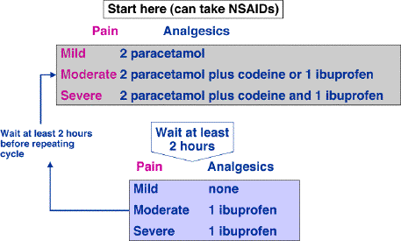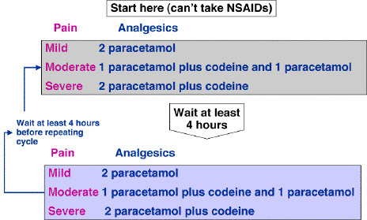

COST - 1 MONTH 1999 PRICES
PARACETAMOL 2 QDS £1.01
IBUPROFEN 400MG TDS £1.26
DICLOFENAC £2.73
VOLTAROL 50MG TDS £15.31
COPROXAMOL 2 QDS £2.50
PARACET. 2QDS + CODEINE 15MG 1 QDS £4.65
COCODAMOL 8/500 2 QDS £2.62
COCODAMOL 8/500 EFFERVESC. 2 QDS £8.20

PARACET. 2QDS + CODEINE 30MG 1 QDS £5.90
KAPAKE 2 QDS £17.16
SOLPADOL EFF. 2 QDS £21.61

Final points
- If analgesics are ineffective, good evidence exists that adding a tricyclic enhances their effect
- Gabapentin is becoming drug of choice for neuropathic pain because of its ease of use, very few interactions (cf other anticonvulsants) and apart from sedative side effects common to all of this group, few other adverse effects. Individual variation in tolerableness is striking however and doses can range between 600mg and 2,400mg / day.
- Consider other methods of analgesia- TENS is well proven and completely safe, Capsaicin for arthritis really has the only evidence for any rubifacient, acupuncture?

